How to Program the SureBatch Remote
This Remote is programed from Surefire Ag Systems to work with this specific controller. In the event that the remote fails to operate follow these instructions…
Step 1: Locate the create button on the back of remote.
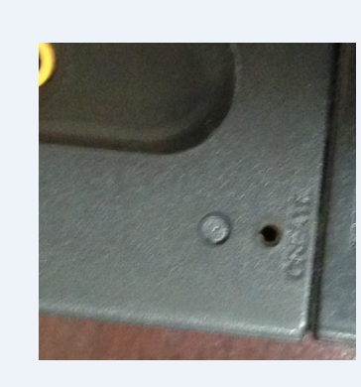
Step 2: Insert paper clip into hole and push button until blue light flashes
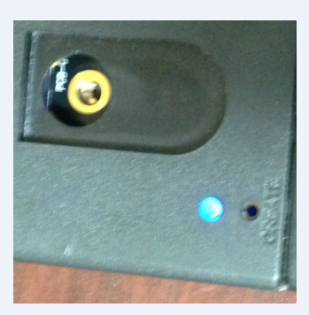
Step 3: While blue light is flashing turn remote over then starting from bottom left push the numbers in numerical order 1 through 8. Number 1 on this remote is the start, button 2 is stop, 3 is above the start button, 4 is above stop, 5 is R3, 6 is R4, 7 is R1 and 8 is R2. Buttons 1-8 must be pushed in numerical order while the blue light flashes. This will create a code for the remote.
(Note buttons 1 & 3 are hidden by sticker see picture below)
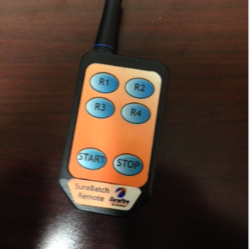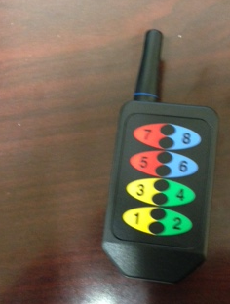

Step 4: Learning the remote. Power up the SureBatch Controller. Select the run tab.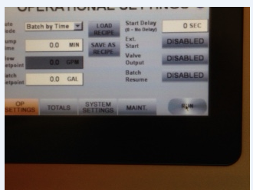
Step 5: Select the setup tab.
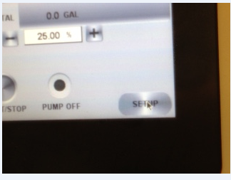
Step 6: Select the Maint. Tab
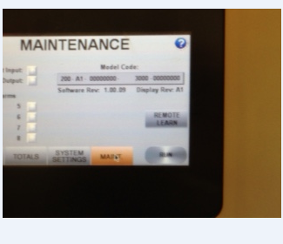
Step 7: Select the learn remote tab and a blue light under the power button will flash, while flashing hold down the start button until the green light turns on.
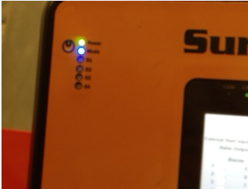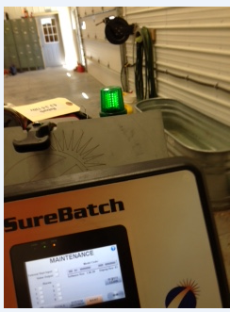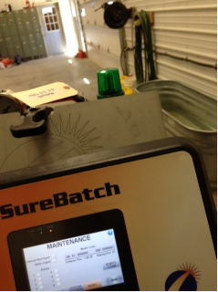
Your remote should now be synced with the controller.

